可加载模块

1.1 Linux内核的模块机制
- LKM：Loadable Kernel Module
内核模块化、高度可定制化和裁剪
适配不同的架构、硬件平台
支持运行时动态加载或卸载一个模块
不需要重新编译、重启内核

1.2 实验：hello模块
- 目标：
一个内核模块的编译和运行，动态加载、动态卸载。
- 添加hello.c文件，路径和内容如下：
ubuntu@VM-8-3-ubuntu:~/wuxiang/code_folder$ cd kernel/drivers/00hello/
ubuntu@VM-8-3-ubuntu:~/wuxiang/code_folder/kernel/drivers/00hello$ pwd
/home/ubuntu/wuxiang/code_folder/kernel/drivers/00hello
ubuntu@VM-8-3-ubuntu:~/wuxiang/code_folder/kernel/drivers/00hello$ ls hello.c
hello.c
ubuntu@VM-8-3-ubuntu:~/wuxiang/code_folder/kernel/drivers/00hello$

#include <linux/init.h>
#include <linux/module.h>

static int __init hello_init(void)
{
printk("Hello world\n");
return 0;
}

static void __exit hello_exit(void)
{
printk("Goodbye world\n");
}

module_init(hello_init);
module_exit(hello_exit);

// MODULE_LICENSE("GPL");
MODULE_AUTHOR("uwu16");
.PHONY : all clean

obj-m := hello.o

EXTRA_CFLAGS += -DDEBUG
# KDIR := ${PWD}/../../linux-5.10.4

all:
make -C $(KDIR) M=$(PWD) modules
# clean:
# make -C $(KDIR) M=$(PWD) modules clean

clean:
@rm -rf *.o *~ .depend .*.cmd *.mod *.mod.c .tmp_versions *.ko *.symvers modules.order
- 到代码根目录进入build目录下：
sudo cmake ..
sudo make kernel drivers rootfs
- 到代码根目录下进入out目录下：
sudo ./start.sh
得到实验结果：
[root@vexpress drivers]# pwd
/my_data/drivers
[root@vexpress drivers]# ls
hello.ko
[root@vexpress drivers]# insmod hello.ko
hello: loading out-of-tree module taints kernel.
hello: module license 'unspecified' taints kernel.
Disabling lock debugging due to kernel taint
Hello world
[root@vexpress drivers]# lsmod
hello 16384 0 - Live 0x7f000000 (PO)
[root@vexpress drivers]# rmmod hello.ko
Goodbye world
[root@vexpress drivers]#

1.3 内核模块的构成
- hello_init
-- 模块加载入口函数，主要完成模块初始化工作
-- 使用 __init声明，使用module_init指定
-- 模块被加载到内核时，入口函数自动被内核执行
-- 返回值：errno
-- 应用层可根据返回值，使用 perror 进行解析
- hello_exit
-- 模块卸载函数，模块卸载时该函数自动被内核执行
-- 使用 __exit声明，使用module_exit指定
-- 主要完成结束模块运行的相关工作、清理各种资源
-- 返回类型：void
- insmod
- lsmod
- rmmod

2. 内核许可声明
用来描述内核的许可权限：内核以GPL发布
模块不声明LICENSE，内核会有(kernel tainted)警告
内核状态此时是受污染的（dirty）
内核受污染后，一些调试、打印功能可能会失效

2.1 协议分类
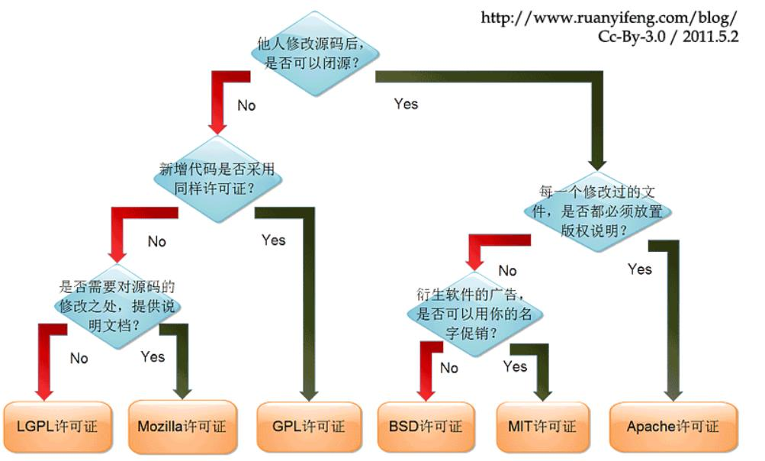

2.2 内核污染（kernel tainted）

2.2.1 cat /proc/sys/kernel/tainted
[root@vexpress ]# cat /proc/sys/kernel/tainted
0
[root@vexpress ]# cd my_data/drivers/
[root@vexpress drivers]#
[root@vexpress drivers]#
[root@vexpress drivers]# ls
hello.ko
[root@vexpress drivers]# insmod hello.ko
hello: loading out-of-tree module taints kernel.
hello: module license 'unspecified' taints kernel.
Disabling lock debugging due to kernel taint
Hello world
[root@vexpress drivers]# cat /proc/sys/kernel/tainted
4097
[root@vexpress drivers]#

2.2.2 内核被污染的原因
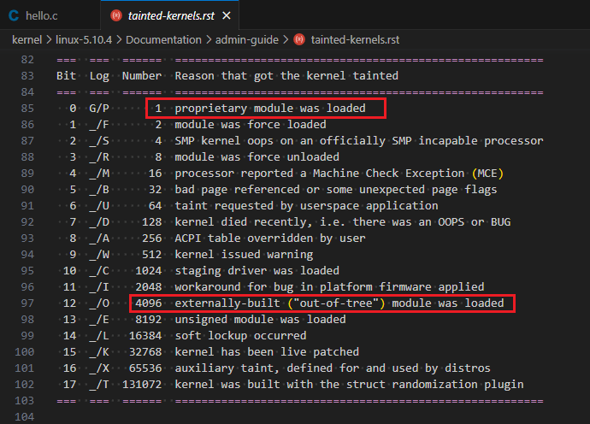

模块签名机制
- 在make_kernel.sh中添加：make menuconfig
ubuntu@VM-8-3-ubuntu:~/wuxiang/code_folder/kernel$ git diff make_kernel.sh
diff --git a/kernel/make_kernel.sh b/kernel/make_kernel.sh
index 7434ede7e..bc8ff3ef6 100755
--- a/kernel/make_kernel.sh
+++ b/kernel/make_kernel.sh
@@ -17,6 +17,7 @@ make_kernel() {
cd ./linux-5.10.4
# make clean
make vexpress_defconfig
+ make menuconfig
make zImage -j8
make modules -j8
make dtbs -j8
ubuntu@VM-8-3-ubuntu:~/wuxiang/code_folder/kernel$
- 打开如下选项：
CONFIG_MODULE_SIG
CONFIG_MODULE_SIG_FORCE
CONFIG_MODULE_SIG_ALL
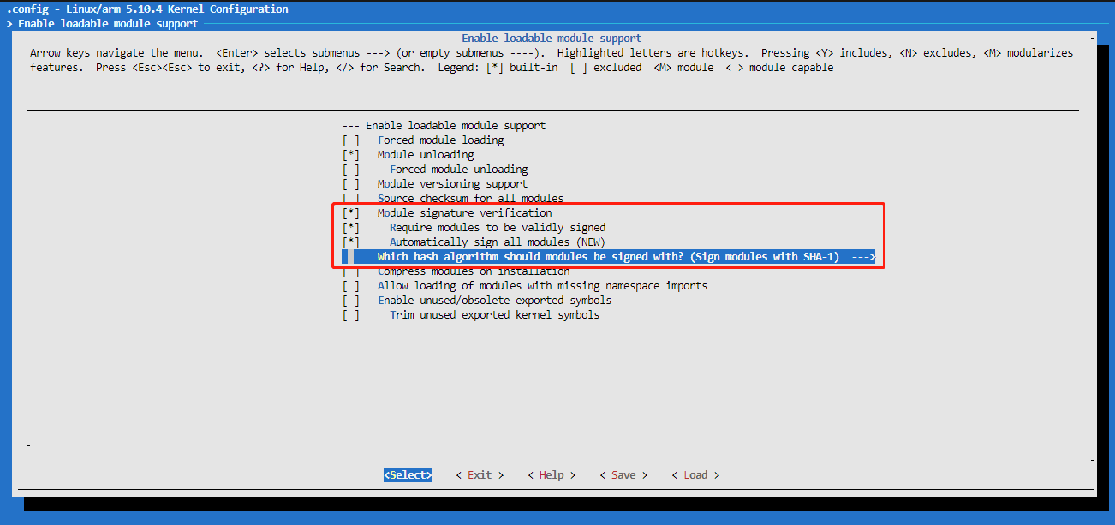
- 未签名的hello.ko
[root@vexpress drivers]# insmod hello.ko
hello: Loading of unsigned module is rejected
insmod: can't insert 'hello.ko': Key was rejected by service
[root@vexpress drivers]#
- 查看签名需要的文件：
ubuntu@VM-8-3-ubuntu:~/wuxiang/code_folder/kernel/linux-5.10.4/certs$ ls signing_key.*
signing_key.pem signing_key.x509
ubuntu@VM-8-3-ubuntu:~/wuxiang/code_folder/kernel/linux-5.10.4/certs$
- certs/signing_key.x509 公钥
- certs/signing_key.pem 私钥
- scripts/sign-file 签名工具
ubuntu@VM-8-3-ubuntu:~/wuxiang/code_folder/kernel/linux-5.10.4/scripts$ ls sign-*
sign-file sign-file.c
ubuntu@VM-8-3-ubuntu:~/wuxiang/code_folder/kernel/linux-5.10.4/scripts$
- 手工给模块签名
（1）签名前：
ubuntu@VM-8-3-ubuntu:~/wuxiang/code_folder/kernel/drivers/00hello$ hexdump -C hello.ko | tail
00014990 00 00 00 00 00 00 00 00 01 00 00 00 00 00 00 00 |................|
000149a0 01 00 00 00 02 00 00 00 00 00 00 00 00 00 00 00 |................|
000149b0 74 f9 00 00 50 03 00 00 26 00 00 00 30 00 00 00 |t...P...&...0...|
000149c0 04 00 00 00 10 00 00 00 09 00 00 00 03 00 00 00 |................|
000149d0 00 00 00 00 00 00 00 00 c4 fc 00 00 e3 00 00 00 |................|
000149e0 00 00 00 00 00 00 00 00 01 00 00 00 00 00 00 00 |................|
000149f0 11 00 00 00 03 00 00 00 00 00 00 00 00 00 00 00 |................|
00014a00 40 42 01 00 97 01 00 00 00 00 00 00 00 00 00 00 |@B..............|
00014a10 01 00 00 00 00 00 00 00 |........|
00014a18
ubuntu@VM-8-3-ubuntu:~/wuxiang/code_folder/kernel/drivers/00hello$
（2）签名：
ubuntu@VM-8-3-ubuntu:~/wuxiang/code_folder/kernel/drivers/00hello$ sudo ../../linux-5.10.4/scripts/sign-file sha1 ../../linux-5.10.4/certs/signing_key.pem ../../linux-5.10.4/certs/signin
g_key.x509 hello.ko
ubuntu@VM-8-3-ubuntu:~/wuxiang/code_folder/kernel/drivers/00hello$
（3）签名后：
ubuntu@VM-8-3-ubuntu:~/wuxiang/code_folder/kernel/drivers/00hello$ hexdump -C hello.ko | tail
00014c60 ac 93 36 2e 7c 67 a1 e5 3d 8f 5f bb 82 3b 2e 3a |..6.|g..=._..;.:|
00014c70 80 01 38 34 3f 07 46 60 06 43 68 3b 8f 7c 61 c8 |..84?.F`.Ch;.|a.|
00014c80 97 38 9b 34 a0 dd bd ba 53 bc 03 12 cf a1 a5 77 |.8.4....S......w|
00014c90 81 ee d4 78 17 d2 44 23 cb 68 2f fe 37 79 77 04 |...x..D#.h/.7yw.|
00014ca0 71 b7 6d b9 63 40 20 70 ba e6 52 a8 d0 72 e0 0b |q.m.c@ p..R..r..|
00014cb0 ed 74 9f 07 3e be ef 35 0b 00 00 02 00 00 00 00 |.t..>..5........|
00014cc0 00 00 00 02 a1 7e 4d 6f 64 75 6c 65 20 73 69 67 |.....~Module sig|
00014cd0 6e 61 74 75 72 65 20 61 70 70 65 6e 64 65 64 7e |nature appended~|
00014ce0 0a |.|
00014ce1
ubuntu@VM-8-3-ubuntu:~/wuxiang/code_folder/kernel/drivers/00hello$
- 签名的hello.ko
拷贝签名的hello.ko到out目录下，执行sudo make rootfs，将其编译到文件系统中，然后启动qemu。
[root@vexpress drivers]# insmod hello.ko
hello: loading out-of-tree module taints kernel.
hello: module license 'unspecified' taints kernel.
Disabling lock debugging due to kernel taint
Hello world
[root@vexpress drivers]#
- 补充：
清除模块签名：
ubuntu@VM-8-3-ubuntu:~/wuxiang/code_folder/kernel/drivers/00hello$ hexdump -C hello.ko | tail
00014c60 ac 93 36 2e 7c 67 a1 e5 3d 8f 5f bb 82 3b 2e 3a |..6.|g..=._..;.:|
00014c70 80 01 38 34 3f 07 46 60 06 43 68 3b 8f 7c 61 c8 |..84?.F`.Ch;.|a.|
00014c80 97 38 9b 34 a0 dd bd ba 53 bc 03 12 cf a1 a5 77 |.8.4....S......w|
00014c90 81 ee d4 78 17 d2 44 23 cb 68 2f fe 37 79 77 04 |...x..D#.h/.7yw.|
00014ca0 71 b7 6d b9 63 40 20 70 ba e6 52 a8 d0 72 e0 0b |q.m.c@ p..R..r..|
00014cb0 ed 74 9f 07 3e be ef 35 0b 00 00 02 00 00 00 00 |.t..>..5........|
00014cc0 00 00 00 02 a1 7e 4d 6f 64 75 6c 65 20 73 69 67 |.....~Module sig|
00014cd0 6e 61 74 75 72 65 20 61 70 70 65 6e 64 65 64 7e |nature appended~|
00014ce0 0a |.|
00014ce1
ubuntu@VM-8-3-ubuntu:~/wuxiang/code_folder/kernel/drivers/00hello$ strip --strip-debug hello.ko
strip: Unable to recognise the format of the input file `hello.ko'
ubuntu@VM-8-3-ubuntu:~/wuxiang/code_folder/kernel/drivers/00hello$ ../../../toolchain/gcc-linaro-7.5.0-2019.12-x86_64_arm-linux-gnueabi/bin/arm-linux-gnueabi-strip --strip-debug hello.ko
ubuntu@VM-8-3-ubuntu:~/wuxiang/code_folder/kernel/drivers/00hello$ hexdump -C hello.ko | tail
00000ce0 00 00 00 00 00 00 00 00 01 00 00 00 00 00 00 00 |................|
00000cf0 01 00 00 00 02 00 00 00 00 00 00 00 00 00 00 00 |................|
00000d00 00 04 00 00 b0 02 00 00 1a 00 00 00 26 00 00 00 |............&...|
00000d10 04 00 00 00 10 00 00 00 09 00 00 00 03 00 00 00 |................|
00000d20 00 00 00 00 00 00 00 00 b0 06 00 00 cf 00 00 00 |................|
00000d30 00 00 00 00 00 00 00 00 01 00 00 00 00 00 00 00 |................|
00000d40 11 00 00 00 03 00 00 00 00 00 00 00 00 00 00 00 |................|
00000d50 e0 07 00 00 28 01 00 00 00 00 00 00 00 00 00 00 |....(...........|
00000d60 01 00 00 00 00 00 00 00 |........|
00000d68
ubuntu@VM-8-3-ubuntu:~/wuxiang/code_folder/kernel/drivers/00hello$

将模块编译进内核
- 代码根目录进入如下目录，新建hello.c文件（内容同上），并修改KConfig和Makefile
ubuntu@VM-8-3-ubuntu:~/wuxiang/code_folder/kernel/linux-5.10.4/drivers/char$ git diff Kconfig
diff --git a/kernel/linux-5.10.4/drivers/char/Kconfig b/kernel/linux-5.10.4/drivers/char/Kconfig
index d229a2d0c..dc35d91e6 100644
--- a/kernel/linux-5.10.4/drivers/char/Kconfig
+++ b/kernel/linux-5.10.4/drivers/char/Kconfig
@@ -22,6 +22,12 @@ config TTY_PRINTK

If unsure, say N.

+config HELLO
+ bool "A hello module test"
+ default n
+ help
+ a simple kernel module test
+
config TTY_PRINTK_LEVEL
depends on TTY_PRINTK
int "ttyprintk log level (1-7)"
ubuntu@VM-8-3-ubuntu:~/wuxiang/code_folder/kernel/linux-5.10.4/drivers/char$
ubuntu@VM-8-3-ubuntu:~/wuxiang/code_folder/kernel/linux-5.10.4/drivers/char$ git diff Makefile
diff --git a/kernel/linux-5.10.4/drivers/char/Makefile b/kernel/linux-5.10.4/drivers/char/Makefile
index ffce287ef..a91edf6b3 100644
--- a/kernel/linux-5.10.4/drivers/char/Makefile
+++ b/kernel/linux-5.10.4/drivers/char/Makefile
@@ -47,3 +47,5 @@ obj-$(CONFIG_PS3_FLASH) += ps3flash.o
obj-$(CONFIG_XILLYBUS) += xillybus/
obj-$(CONFIG_POWERNV_OP_PANEL) += powernv-op-panel.o
obj-$(CONFIG_ADI) += adi.o
+
+obj-${CONFIG_HELLO} += hello.o
ubuntu@VM-8-3-ubuntu:~/wuxiang/code_folder/kernel/linux-5.10.4/drivers/char$
ubuntu@VM-8-3-ubuntu:~/wuxiang/code_folder/kernel$ git diff make_kernel.sh
diff --git a/kernel/make_kernel.sh b/kernel/make_kernel.sh
index 7434ede7e..bc8ff3ef6 100755
--- a/kernel/make_kernel.sh
+++ b/kernel/make_kernel.sh
@@ -17,6 +17,7 @@ make_kernel() {
cd ./linux-5.10.4
# make clean
make vexpress_defconfig
+ make menuconfig
make zImage -j8
make modules -j8
make dtbs -j8
ubuntu@VM-8-3-ubuntu:~/wuxiang/code_folder/kernel$
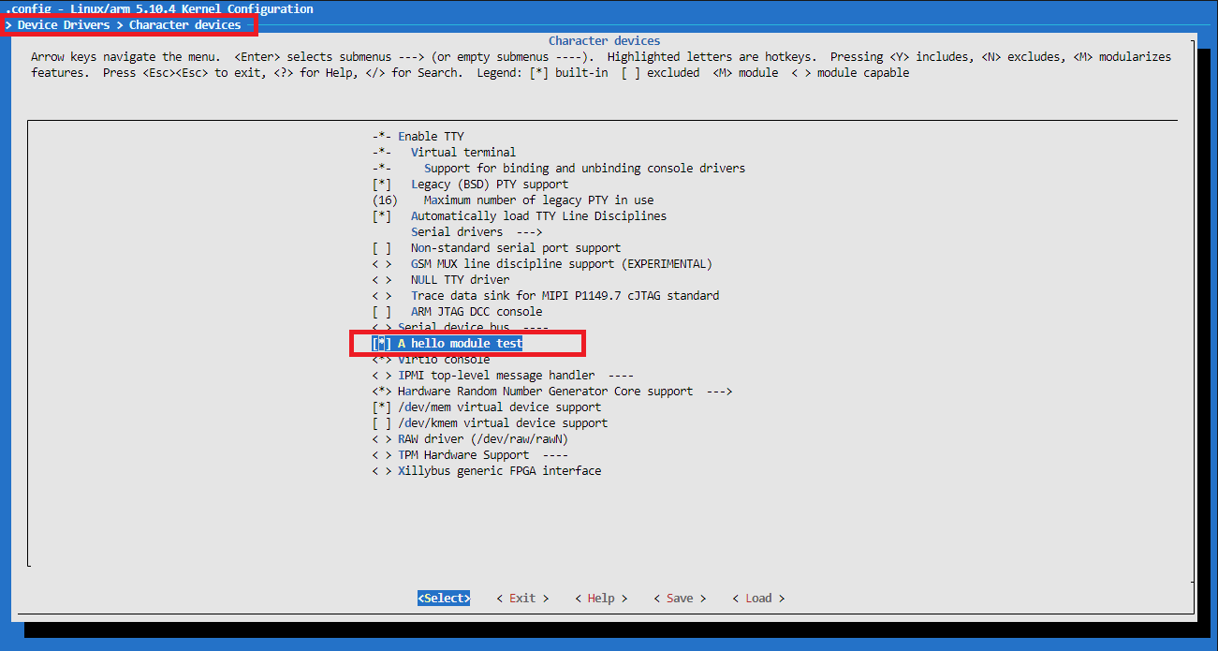
- dmesg显示开机信息：
[root@vexpress ]# dmesg | grep "Hello world"
Hello world
[root@vexpress ]#
完整的开机信息如下：（Hello world在110行）
[root@vexpress ]# dmesg
Booting Linux on physical CPU 0x0
Linux version 5.10.4 (root@VM-8-3-ubuntu) (arm-linux-gnueabi-gcc (Linaro GCC 7.5-2019.12) 7.5.0, GNU ld (Linaro_Binutils-2019.12) 2.28.2.20170706) #7 SMP Tue Aug 8 22:04:14 CST 2023
CPU: ARMv7 Processor [410fc090] revision 0 (ARMv7), cr=10c5387d
CPU: PIPT / VIPT nonaliasing data cache, VIPT nonaliasing instruction cache
OF: fdt: Machine model: V2P-CA9
Malformed early option 'earlycon'
printk: debug: ignoring loglevel setting.
Memory policy: Data cache writeback
Reserved memory: created DMA memory pool at 0x4c000000, size 8 MiB
OF: reserved mem: initialized node vram@4c000000, compatible id shared-dma-pool
cma: Reserved 16 MiB at 0x9f000000
Zone ranges:
Normal [mem 0x0000000060000000-0x000000009fffffff]
Movable zone start for each node
Early memory node ranges
node 0: [mem 0x0000000060000000-0x000000009fffffff]
Initmem setup node 0 [mem 0x0000000060000000-0x000000009fffffff]
On node 0 totalpages: 262144
Normal zone: 2048 pages used for memmap
Normal zone: 0 pages reserved
Normal zone: 262144 pages, LIFO batch:63
CPU: All CPU(s) started in SVC mode.
percpu: Embedded 19 pages/cpu s46156 r8192 d23476 u77824
pcpu-alloc: s46156 r8192 d23476 u77824 alloc=19*4096
pcpu-alloc: [0] 0 [0] 1 [0] 2 [0] 3
Built 1 zonelists, mobility grouping on. Total pages: 260096
Kernel command line: root=/dev/mmcblk0p2 rw rootfstype=ext4 rootwait earlycon console=tty0 console=ttyAMA0 init=/linuxrc ignore_loglevel
printk: log_buf_len individual max cpu contribution: 4096 bytes
printk: log_buf_len total cpu_extra contributions: 12288 bytes
printk: log_buf_len min size: 16384 bytes
printk: log_buf_len: 32768 bytes
printk: early log buf free: 14628(89%)
Dentry cache hash table entries: 131072 (order: 7, 524288 bytes, linear)
Inode-cache hash table entries: 65536 (order: 6, 262144 bytes, linear)
mem auto-init: stack:off, heap alloc:off, heap free:off
Memory: 1011660K/1048576K available (7168K kernel code, 583K rwdata, 1720K rodata, 1024K init, 184K bss, 20532K reserved, 16384K cma-reserved)
SLUB: HWalign=64, Order=0-3, MinObjects=0, CPUs=4, Nodes=1
rcu: Hierarchical RCU implementation.
rcu: RCU event tracing is enabled.
rcu: RCU restricting CPUs from NR_CPUS=8 to nr_cpu_ids=4.
rcu: RCU calculated value of scheduler-enlistment delay is 10 jiffies.
rcu: Adjusting geometry for rcu_fanout_leaf=16, nr_cpu_ids=4
NR_IRQS: 16, nr_irqs: 16, preallocated irqs: 16
GIC CPU mask not found - kernel will fail to boot.
GIC CPU mask not found - kernel will fail to boot.
L2C: platform modifies aux control register: 0x02020000 -> 0x02420000
L2C: DT/platform modifies aux control register: 0x02020000 -> 0x02420000
L2C-310 enabling early BRESP for Cortex-A9
L2C-310 full line of zeros enabled for Cortex-A9
L2C-310 dynamic clock gating disabled, standby mode disabled
L2C-310 cache controller enabled, 8 ways, 128 kB
L2C-310: CACHE_ID 0x410000c8, AUX_CTRL 0x46420001
random: get_random_bytes called from start_kernel+0x388/0x52c with crng_init=0
sched_clock: 32 bits at 24MHz, resolution 41ns, wraps every 89478484971ns
clocksource: arm,sp804: mask: 0xffffffff max_cycles: 0xffffffff, max_idle_ns: 1911260446275 ns
Failed to initialize '/bus@4000000/motherboard/iofpga@7,00000000/timer@12000': -22
smp_twd: clock not found -2
Console: colour dummy device 80x30
printk: console [tty0] enabled
Calibrating local timer... 90.81MHz.
Calibrating delay loop... 609.07 BogoMIPS (lpj=3045376)
pid_max: default: 32768 minimum: 301
Mount-cache hash table entries: 2048 (order: 1, 8192 bytes, linear)
Mountpoint-cache hash table entries: 2048 (order: 1, 8192 bytes, linear)
CPU: Testing write buffer coherency: ok
CPU0: Spectre v2: using BPIALL workaround
CPU0: thread -1, cpu 0, socket 0, mpidr 80000000
Setting up static identity map for 0x60100000 - 0x60100060
rcu: Hierarchical SRCU implementation.
smp: Bringing up secondary CPUs ...
smp: Brought up 1 node, 1 CPU
SMP: Total of 1 processors activated (609.07 BogoMIPS).
CPU: All CPU(s) started in SVC mode.
devtmpfs: initialized
VFP support v0.3: implementor 41 architecture 3 part 30 variant 9 rev 0
clocksource: jiffies: mask: 0xffffffff max_cycles: 0xffffffff, max_idle_ns: 19112604462750000 ns
futex hash table entries: 1024 (order: 4, 65536 bytes, linear)
NET: Registered protocol family 16
DMA: preallocated 256 KiB pool for atomic coherent allocations
cpuidle: using governor ladder
hw-breakpoint: debug architecture 0x4 unsupported.
Serial: AMBA PL011 UART driver
SCSI subsystem initialized
libata version 3.00 loaded.
usbcore: registered new interface driver usbfs
usbcore: registered new interface driver hub
usbcore: registered new device driver usb
Advanced Linux Sound Architecture Driver Initialized.
clocksource: Switched to clocksource arm,sp804
NET: Registered protocol family 2
tcp_listen_portaddr_hash hash table entries: 512 (order: 0, 6144 bytes, linear)
TCP established hash table entries: 8192 (order: 3, 32768 bytes, linear)
TCP bind hash table entries: 8192 (order: 4, 65536 bytes, linear)
TCP: Hash tables configured (established 8192 bind 8192)
UDP hash table entries: 512 (order: 2, 16384 bytes, linear)
UDP-Lite hash table entries: 512 (order: 2, 16384 bytes, linear)
NET: Registered protocol family 1
RPC: Registered named UNIX socket transport module.
RPC: Registered udp transport module.
RPC: Registered tcp transport module.
RPC: Registered tcp NFSv4.1 backchannel transport module.
hw perfevents: enabled with armv7_cortex_a9 PMU driver, 5 counters available
workingset: timestamp_bits=30 max_order=18 bucket_order=0
squashfs: version 4.0 (2009/01/31) Phillip Lougher
jffs2: version 2.2. (NAND) © 2001-2006 Red Hat, Inc.
9p: Installing v9fs 9p2000 file system support
io scheduler mq-deadline registered
io scheduler kyber registered
Hello world
i2c i2c-0: Added multiplexed i2c bus 2
physmap-flash 40000000.flash: physmap platform flash device: [mem 0x40000000-0x43ffffff]
40000000.flash: Found 2 x16 devices at 0x0 in 32-bit bank. Manufacturer ID 0x000000 Chip ID 0x000000
Intel/Sharp Extended Query Table at 0x0031
Using buffer write method
erase region 0: offset=0x0,size=0x40000,blocks=256
physmap-flash 40000000.flash: physmap platform flash device: [mem 0x44000000-0x47ffffff]
40000000.flash: Found 2 x16 devices at 0x0 in 32-bit bank. Manufacturer ID 0x000000 Chip ID 0x000000
Intel/Sharp Extended Query Table at 0x0031
Using buffer write method
erase region 0: offset=0x0,size=0x40000,blocks=256
Concatenating MTD devices:
(0): "40000000.flash"
(1): "40000000.flash"
into device "40000000.flash"
physmap-flash 48000000.psram: physmap platform flash device: [mem 0x48000000-0x49ffffff]
libphy: Fixed MDIO Bus: probed
libphy: smsc911x-mdio: probed
smsc911x 4e000000.ethernet eth0: MAC Address: 52:54:00:12:34:56
isp1760 4f000000.usb: bus width: 32, oc: digital
isp1760 4f000000.usb: NXP ISP1760 USB Host Controller
isp1760 4f000000.usb: new USB bus registered, assigned bus number 1
isp1760 4f000000.usb: Scratch test failed.
isp1760 4f000000.usb: can't setup: -19
isp1760 4f000000.usb: USB bus 1 deregistered
usbcore: registered new interface driver usb-storage
ledtrig-cpu: registered to indicate activity on CPUs
usbcore: registered new interface driver usbhid
usbhid: USB HID core driver
NET: Registered protocol family 17
9pnet: Installing 9P2000 support
oprofile: using arm/armv7-ca9
Registering SWP/SWPB emulation handler
aaci-pl041 10004000.aaci: ARM AC'97 Interface PL041 rev0 at 0x10004000, irq 28
aaci-pl041 10004000.aaci: FIFO 512 entries
mmci-pl18x 10005000.mmci: Got CD GPIO
mmci-pl18x 10005000.mmci: Got WP GPIO
mmci-pl18x 10005000.mmci: mmc0: PL181 manf 41 rev0 at 0x10005000 irq 29,30 (pio)
10009000.uart: ttyAMA0 at MMIO 0x10009000 (irq = 33, base_baud = 0) is a PL011 rev1
mmc0: new SD card at address 4567
mmcblk0: mmc0:4567 QEMU! 1.00 GiB
printk: console [ttyAMA0] enabled
1000a000.uart: ttyAMA1 at MMIO 0x1000a000 (irq = 34, base_baud = 0) is a PL011 rev1
1000b000.uart: ttyAMA2 at MMIO 0x1000b000 (irq = 35, base_baud = 0) is a PL011 rev1
1000c000.uart: ttyAMA3 at MMIO 0x1000c000 (irq = 36, base_baud = 0) is a PL011 rev1
random: fast init done
input: AT Raw Set 2 keyboard as /devices/platform/bus@4000000/bus@4000000:motherboard/bus@4000000:motherboard:iofpga@7,00000000/10006000.kmi/serio0/input/input0
mmcblk0: p1 p2
rtc-pl031 10017000.rtc: registered as rtc0
rtc-pl031 10017000.rtc: setting system clock to 2023-08-08T14:06:36 UTC (1691503596)
drm-clcd-pl111 1001f000.clcd: assigned reserved memory node vram@4c000000
drm-clcd-pl111 1001f000.clcd: using device-specific reserved memory
drm-clcd-pl111 1001f000.clcd: core tile graphics present
drm-clcd-pl111 1001f000.clcd: this device will be deactivated
drm-clcd-pl111 1001f000.clcd: Versatile Express init failed - -19
drm-clcd-pl111 10020000.clcd: DVI muxed to daughterboard 1 (core tile) CLCD
drm-clcd-pl111 10020000.clcd: initializing Versatile Express PL111
drm-clcd-pl111 10020000.clcd: found bridge on endpoint 0
drm-clcd-pl111 10020000.clcd: Using non-panel bridge
[drm] Initialized pl111 1.0.0 20170317 for 10020000.clcd on minor 0
Console: switching to colour frame buffer device 128x48
drm-clcd-pl111 10020000.clcd: [drm] fb0: pl111drmfb frame buffer device
ALSA device list:
#0: ARM AC'97 Interface PL041 rev0 at 0x10004000, irq 28
input: ImExPS/2 Generic Explorer Mouse as /devices/platform/bus@4000000/bus@4000000:motherboard/bus@4000000:motherboard:iofpga@7,00000000/10007000.kmi/serio1/input/input2
EXT4-fs (mmcblk0p2): mounted filesystem with ordered data mode. Opts: (null)
VFS: Mounted root (ext4 filesystem) on device 179:2.
Freeing unused kernel memory: 1024K
Run /linuxrc as init process
with arguments:
/linuxrc
with environment:
HOME=/
TERM=linux
random: crng init done
[root@vexpress ]#

5.out-of-tree编译
.PHONY : all clean

obj-m := hello.o

EXTRA_CFLAGS += -DDEBUG
# KDIR := ${PWD}/../../linux-5.10.4

all:
make -C $(KDIR) M=$(PWD) modules
# clean:
# make -C $(KDIR) M=$(PWD) modules clean

clean:
@rm -rf *.o *~ .depend .*.cmd *.mod *.mod.c .tmp_versions *.ko *.symvers modules.order

模块的Makefile分析
Kbuild：
obj-y := hello.o
obj-m := hello.o
obj-{CONFIG_HELLO} := hello.o
hello-objs := hello.c sub.c
将Kbuild和Makefile分开：
obj-m := hello_Kbuild.o
.PHONY : all clean

EXTRA_CFLAGS += -DDEBUG
# KDIR := ${PWD}/../../linux-5.10.4

all:
make -C $(KDIR) M=$(PWD) modules
# clean:
# make -C $(KDIR) M=$(PWD) modules clean

clean:
@rm -rf *.o *~ .depend .*.cmd *.mod *.mod.c .tmp_versions *.ko *.symvers modules.order

模块参数

7.1 如何给模块传参数？
#define module_param(name, type, perm) module_param_named(name, name, type, perm)
- name：要传递的参数，对应模块中的全局变量
- type：要传递的参数类型，要和全局变量类型一致
- perm：读写权限
  - /sys/module/hello/parameters/xx 参数节点
  - 0666：读写权限
  - 0444：只读权限，无法对这个文件节点执行写的操作
  - 4-读，2-写，1-执行
#include <linux/init.h>
#include <linux/module.h>
#include <linux/moduleparam.h>

static int num = 10;
module_param(num, int, 0660);

static int __init hello_init(void)
{
printk("Hello world\n");
printk("num = %d\n", num);

return 0;
}

static void __exit hello_exit(void)
{
printk("Goodbye world\n");
printk("num = %d\n", num);
}

module_init(hello_init);
module_exit(hello_exit);

MODULE_LICENSE("GPL");
MODULE_AUTHOR("uwu16");
[root@vexpress drivers]# insmod hello_params.ko
Hello world
num = 10
[root@vexpress drivers]# cd /sys/module/hello_params/parameters/
[root@vexpress parameters]#
[root@vexpress parameters]# ls
num
[root@vexpress parameters]# cat num
10
[root@vexpress parameters]# echo 100 > num
[root@vexpress parameters]# cat num
100
[root@vexpress parameters]# lsmod
hello_params 16384 0 - Live 0x7f000000 (O)
[root@vexpress parameters]# rmmod hello_params
Goodbye world
num = 100
[root@vexpress parameters]# cd /my_data/drivers/
[root@vexpress drivers]# insmod hello_params.ko num=111
Hello world
num = 111
[root@vexpress drivers]# rmmod hello_params.ko
Goodbye world
num = 111
[root@vexpress drivers]#

7.2 通过uboot给模块传参
- 需要使用编译进内核中的hello模块
- 编译uboot时，make menuconfig，在bootargs中添加hello.num=100
- 启动qemu
[root@vexpress ]# dmesg | grep num
Kernel command line: root=/dev/mmcblk0p2 rw rootfstype=ext4 rootwait earlycon console=tty0 console=ttyAMA0 init=/linuxrc ignore_loglevel hello.num=100
num = 100
isp1760 4f000000.usb: new USB bus registered, assigned bus number 1
[root@vexpress ]# dmesg | grep Hello
Hello world
[root@vexpress ]#
- 完整开机log如下：
...
io scheduler mq-deadline registered
io scheduler kyber registered
Hello world
num = 100
i2c i2c-0: Added multiplexed i2c bus 2
...

EXPORT_SYMBOL

8.1 用户空间的模块化编程
函数的实现：math.c/int add(int a, int b)
函数的声明：math.h/int add(int a, int b);
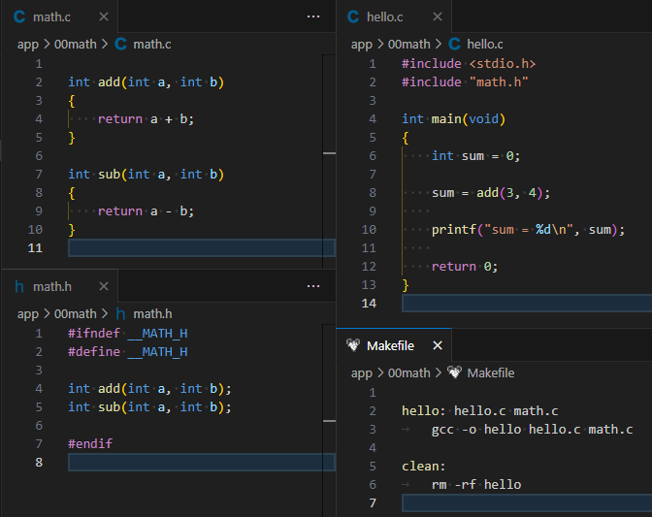

8.2 内核空间的模块化编程
模块的封装：static、EXPORT_SYMBOL
函数的声明：头文件
- 按不同的协议导出符号
EXPORT_SYMBOL
EXPORT_SYMBOL_GPL
-------------------------------------
***** welcome to vexpress board *****
-------------------------------------

Please press Enter to activate this console.
[root@vexpress ]#
[root@vexpress ]#
[root@vexpress ]#
[root@vexpress ]# cd my_data/drivers/
[root@vexpress drivers]#
[root@vexpress drivers]# ls
hello.ko hello_in_kernel.ko hello_params.ko
hello_Kbuild.ko hello_module.ko math_module.ko
[root@vexpress drivers]#
[root@vexpress drivers]#
[root@vexpress drivers]#
[root@vexpress drivers]# insmod math_module.ko
math_module: loading out-of-tree module taints kernel.
Hello math_module
[root@vexpress drivers]# insmod hello_module.ko
num = 10
sum = 7
[root@vexpress drivers]#

模块的版本控制
解决内核模块和内核之间的接口一致性问题
根据函数参数、返回值类型等生成CRC校验码
当内核和模块双方的校验码相等，则为相同接口
内核启动版本控制功能：CONFIG_MODVERSIONS
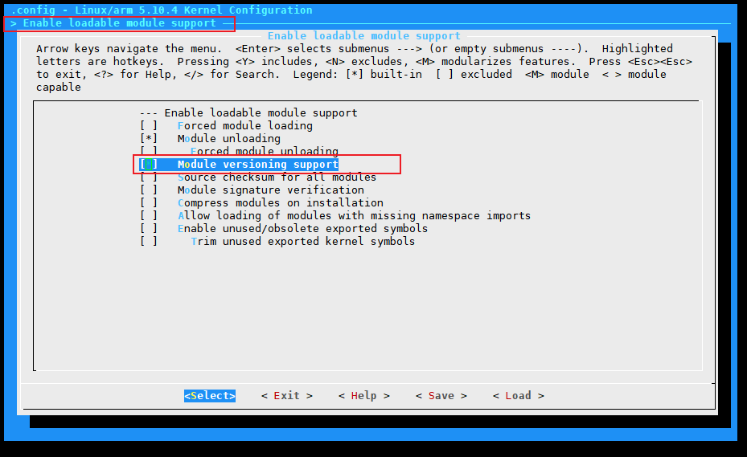
- 实验：版本控制实验
- 不开CONFIG_MODVERSIONS编译内核，基于此内核编译drivers
- 打开CONFIG_MODVERSIONS，不编译drivers
- 使用打开CONFIG_MODVERSIONS的内核和不开CONFIG_MODVERSIONS编译内核后编译的drivers，进行版本控制的实验。
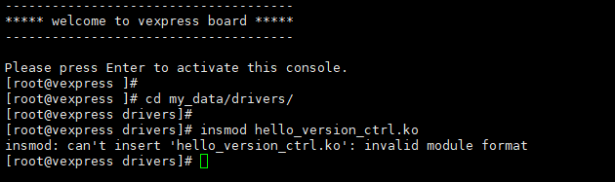
- 相关的几个文件
hello_version_ctrl.mod.c
hello_version_ctrl.ko：__versions section
内核中：Modules.symvers
模块中：Modules.symvers
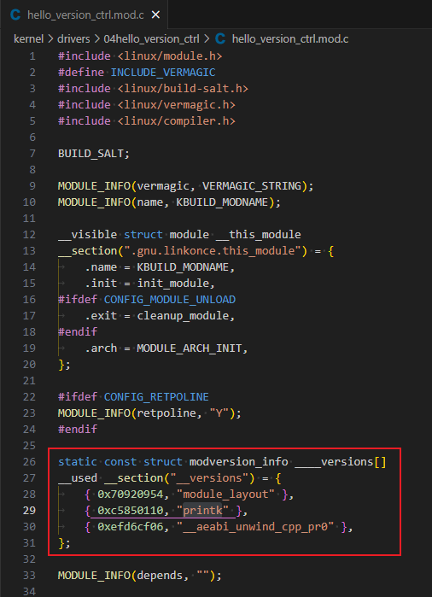
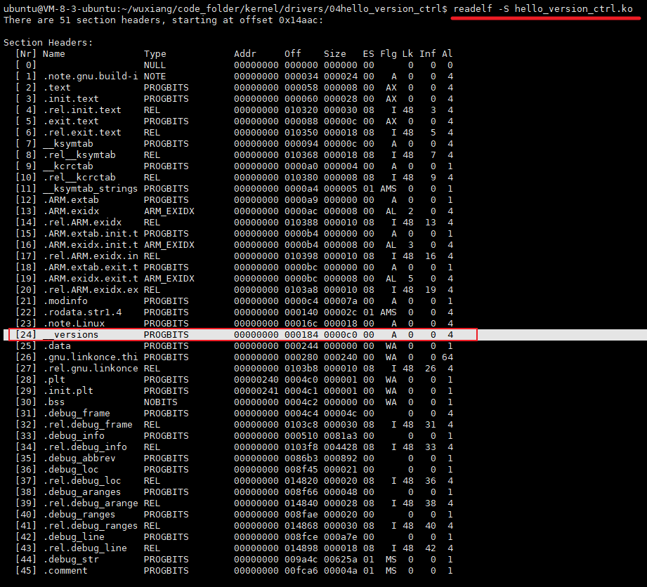
hello_version_ctrl.ko模块中调用的内核中的接口函数以及CRC校验码，当模块被加载到内核中运行的时候，内核就会根据调用的比如printk的校验码和内核中保存的printk的校验码进行比对，比对成功，模块才可以加载到内核中运行。
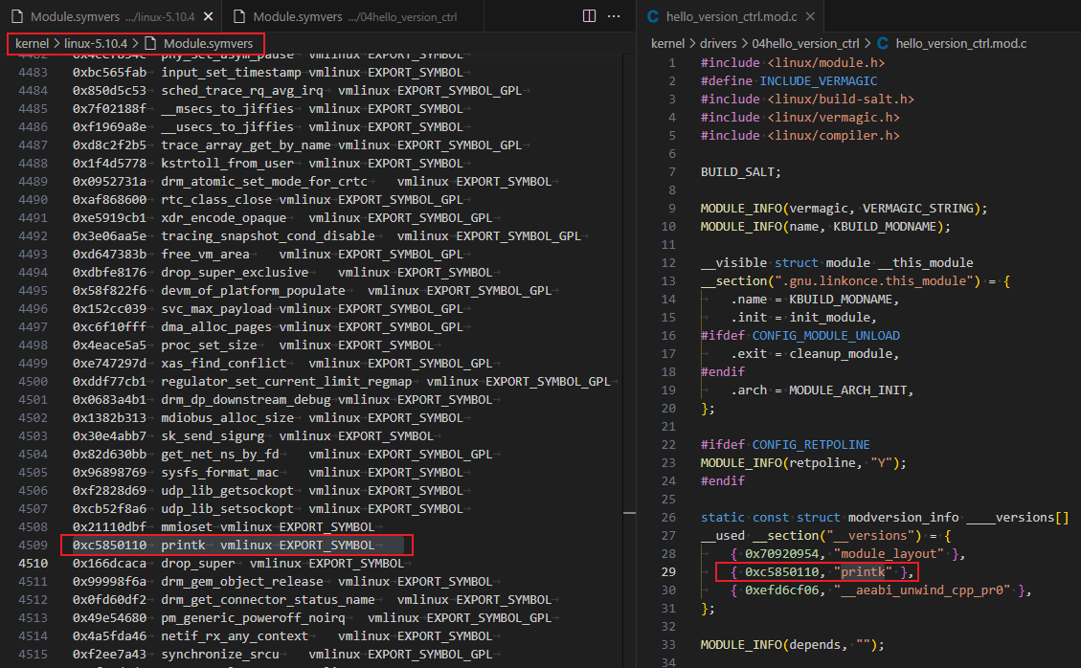
反汇编：
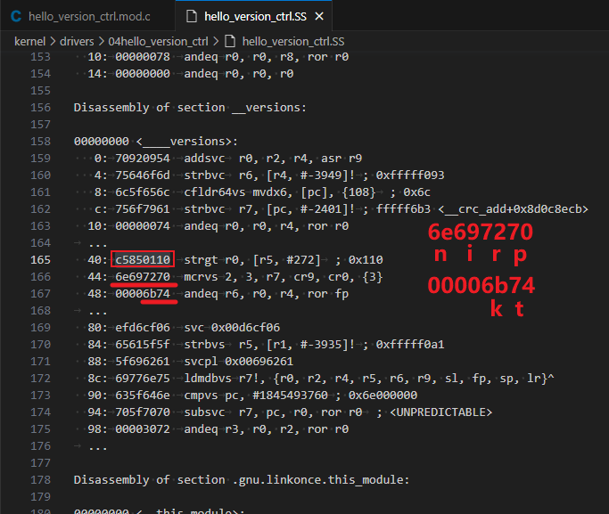
我们自己编译的模块，使用EXPORT_SYMBOL导出的时候，也会生成校验码，别的模块在调用时也会进行校验。
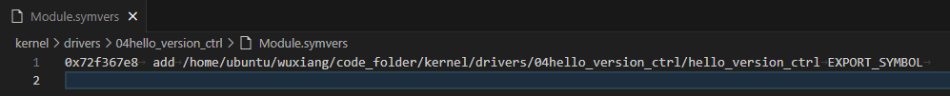

模块的头文件
#include <linux/xx.h>
#include <asm/xx.h>
#include <plat/xx.h>
#include <mach/xx.h>
#include "usb.h"
- 头文件分类
内核专用头文件：include/linux
和CPU架构相关：arch/$(ARCH)/include
板级硬件相关：
arch/$(ARCH)/plat-xx/include
arch/$(ARCH)/mach-xx/include
- 通过GCC -I指定头文件路径
#include <module1/module1.h>
#include <module2/module2.h>
#include <module3/module3.h>

├── a.out
├── inc
│ ├── module1
│ │ └── module1.h
│ ├── module2
│ │ └── module2.h
│ └── module3
│ └── module3.h
├── main.c
├── module1
│ └── module1.c
├── module2
│ └── module2.c
└── module3
└── module3.c
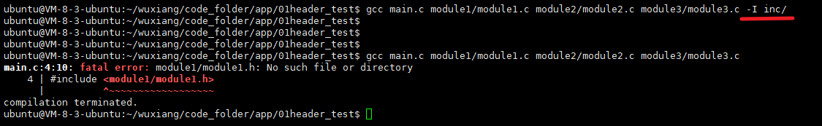
- 内核中的头文件路径
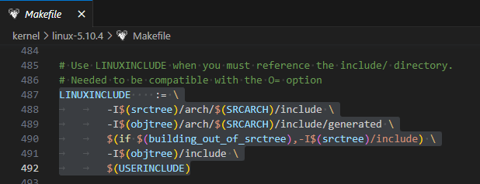
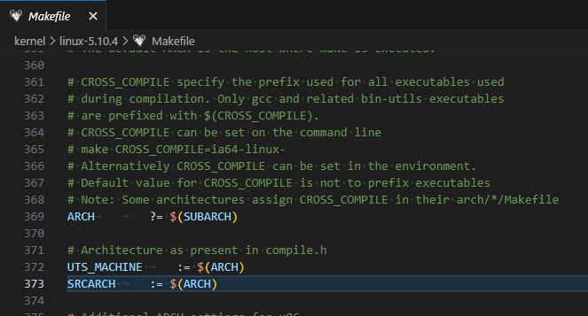
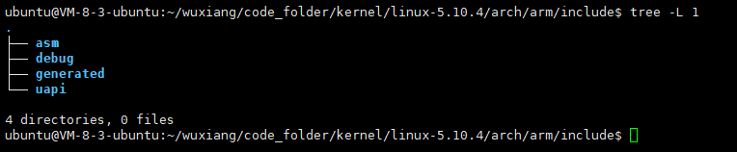

多文件构成的模块
- 编程实验：
- 一个复杂模块往往由多个C文件构成
- 模块内部接口的封装和引用
- 模块如何封装
- 模块间如何引用
- 头文件
- Makefile 的写法
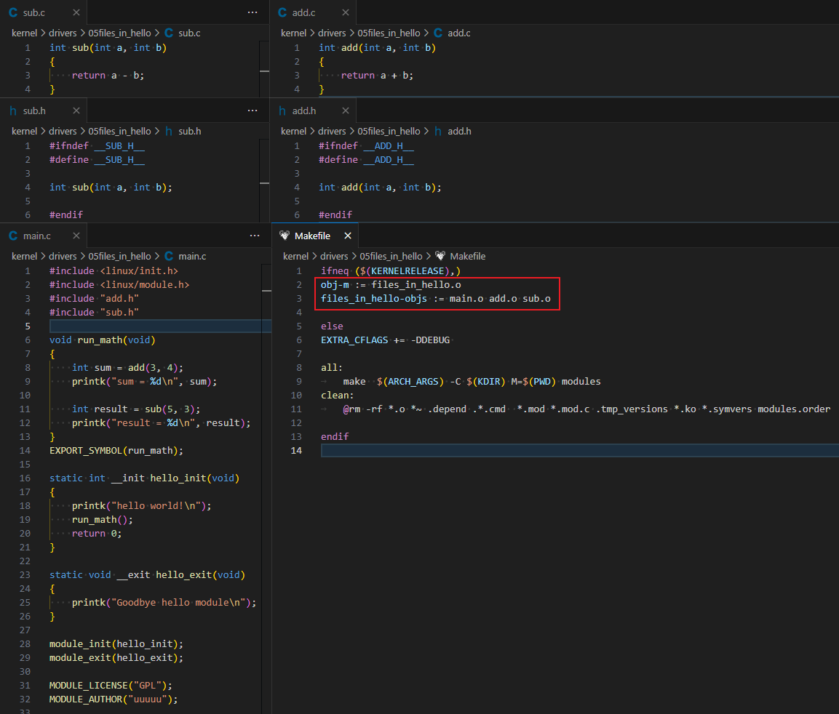
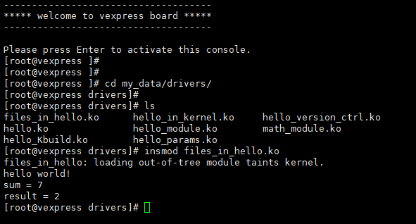

模块间的依赖
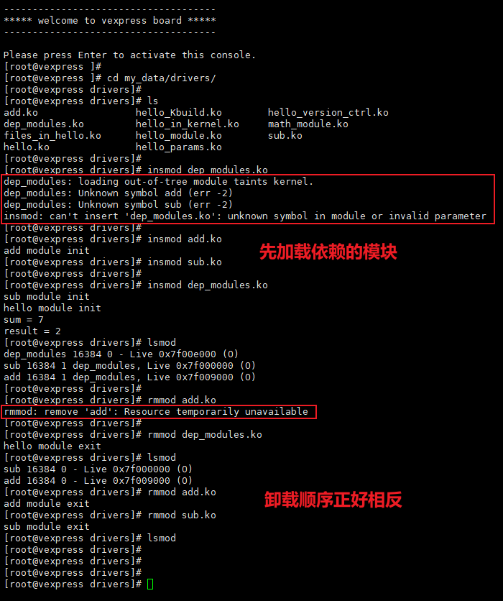
- 生成模块间的依赖关系
depmod –a
depmod会解析/lib/modules/$(kernel_version)下的所有内核模块，通过各个模块EXPORT_SYMBOL和引用的符号，生成一个模块依赖关系表：/lib/modules/$(kernel_version)/modules.dep
modprobe hello # 加载
modprobe –r hello # 卸载
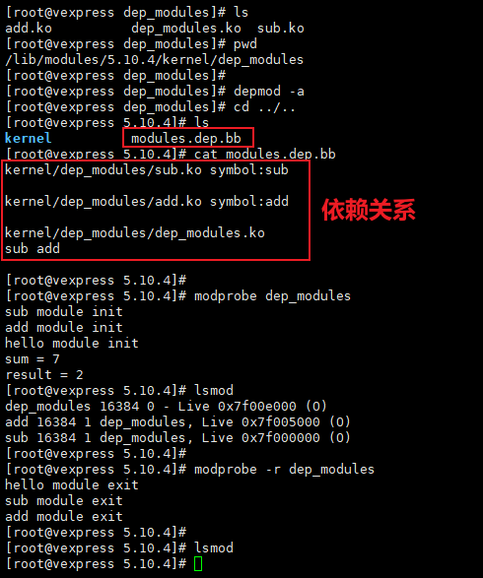

编写一个字符驱动
read / write
sys_read / sys_write
普通文件 | - 设备文件
文件系统 | 设备模型
inode | 设备号
块设备驱动 | 字符设备驱动
- 编程实验：实现一个最简单的字符驱动
驱动源码：实现基本的read、write接口
Makefile编写
创建设备节点
编写应用程序读写设备，看驱动工作是否正常
// hello_char.ko
#include <linux/module.h>
#include <linux/init.h>
#include <linux/fs.h>

static char hello_buf[512] = "0";

static int hello_open(struct inode *inode, struct file *fp)
{
return 0;
}

static int hello_release(struct inode *inode, struct file *fp)
{
return 0;
}

static ssize_t hello_read(struct file *fp, char __user *buf,
size_t size, loff_t *pos)
{
unsigned long p = *pos;
unsigned int count = size;

if (p >= 512) {
return -1;
}

if (count > 512) {
count = 512 - p;
}

if (copy_to_user(buf, hello_buf + p, count) != 0) {
printk("read error!\n");
return -1;
}

return count;
}

static ssize_t hello_write(struct file *fp, const char __user *buf,
size_t size, loff_t *pos)
{
unsigned long p = *pos;
unsigned int count = size;

if (p >= 512) {
return -1;
}

if(count > 512) {
count = 512 - p;
}

if(copy_from_user(hello_buf, buf + p, count) != 0) {
printk("write error!\n");
return -1;
}

return count;
}

static const struct file_operations hello_fops = {
.owner = THIS_MODULE,
.read = hello_read,
.write = hello_write,
.open = hello_open,
.release = hello_release,
};

static int __init hello_init(void)
{
int ret;

ret = register_chrdev(222, "hello_char", &hello_fops);
if (ret < 0) {
printk("Register char module: hello_char failed..\n");
return 0;
} else {
printk("Register char module: hello_char success!\n");
}

return 0;
}

static void __exit hello_exit(void)
{
printk("Goodbye char module: hello_char!\n");
unregister_chrdev(222, "hello_char");
}

module_init(hello_init);
module_exit(hello_exit);
MODULE_LICENSE("GPL");
MODULE_AUTHOR("uuuuu");
#include<stdio.h>
#include<sys/types.h>
#include<sys/stat.h>
#include<fcntl.h>
#include <stdlib.h>
#include <unistd.h>

int main(void)
{
int fd;
int i, ret;
char write_buf[10] = "aaaabbbb";
char read_buf[10] = "0";

fd = open("/dev/hello_char", O_RDWR);
if(fd == -1) {
printf("cannot open file..\n");
exit(1);
}

if ((ret = write(fd, write_buf, 10)) < 0) {
printf("write failed\n");
return -1;
}

lseek(fd, 0, SEEK_SET);
if ((ret = read(fd, read_buf, 10)) < 10) {
printf("read error!\n");
exit(1);
}

printf("%s\n", read_buf);

close(fd);

return 0;
}
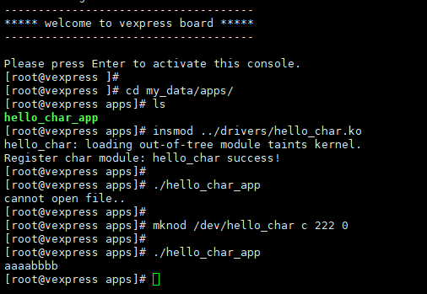

模块的运行过程
- 模块的分类
可加载模块：源码外编译，动态加载、动态卸载
内置模块：直接编译进内核，随内核启动初始化
- 使用dump_stack()打印函数调用栈
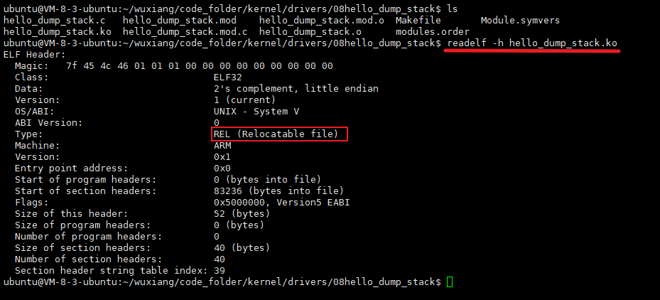
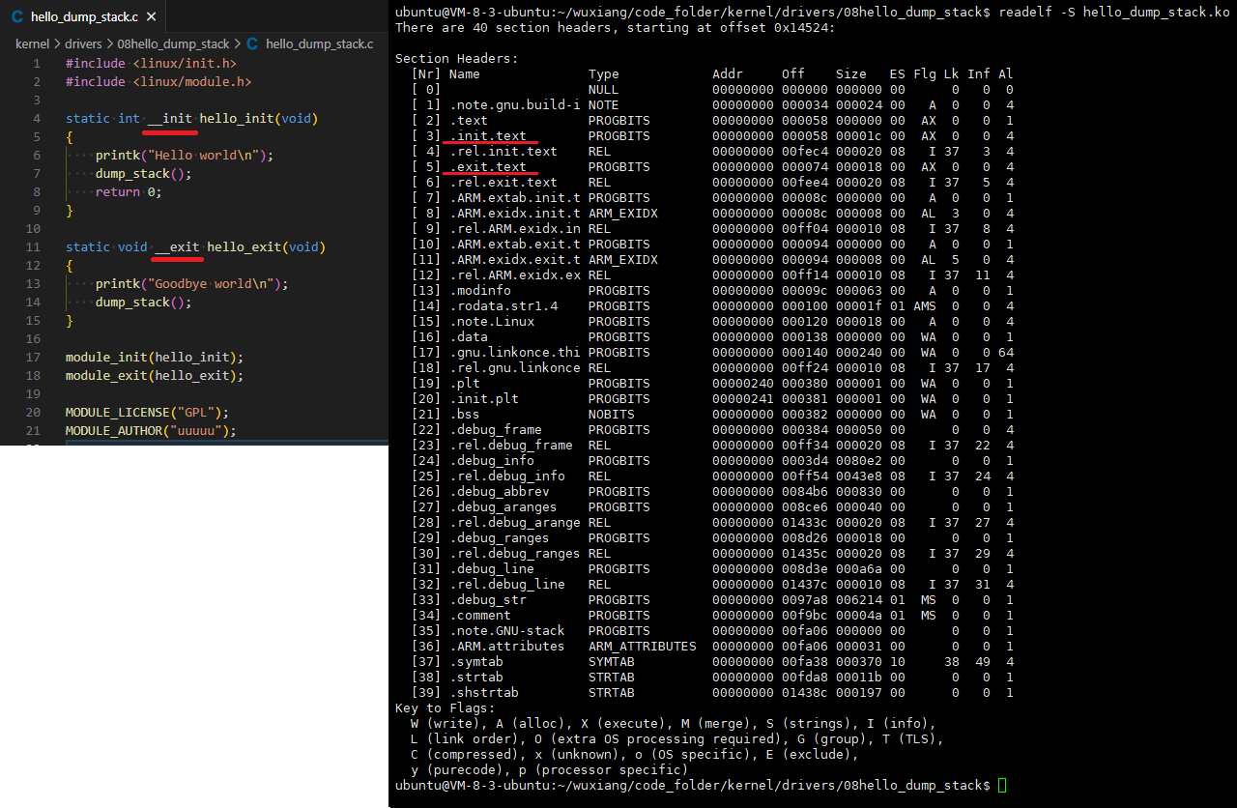
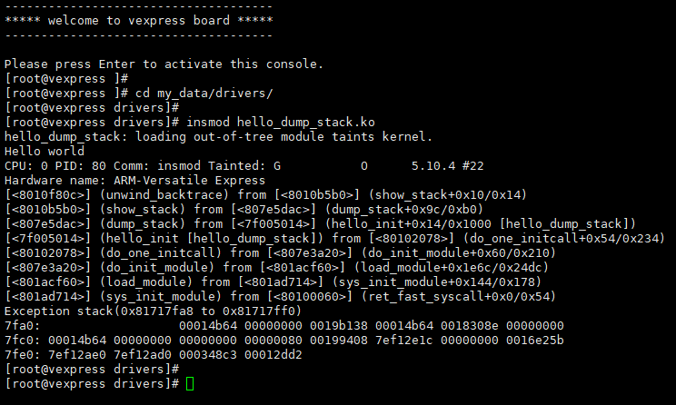

模块机制实现分析
- 分析之前的准备
C语言与链接脚本、Makefile、Kbuild的交互
C语言如何引用链接脚本中定义的符号
C语言如何使用Makefile中定义的符号
C语言如何使用kbuild配置变量
- ???????????????????????????????????????????????
- ???????????????????????????????????????????????
- ???????????????????????????????????????????????
- ???????????????????????????????????????????????

使用模块机制分析内核

